**Accessing a remote service running on a remotely blocked port.**

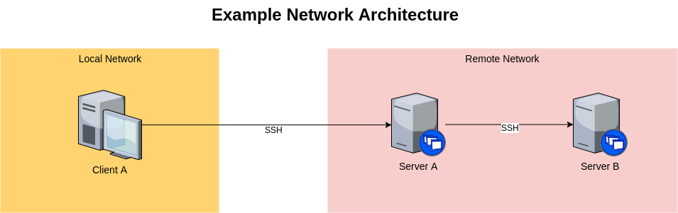

**Notes;**

1. The only allowed connection between Client A and Server A is via SSH. The only allowed connection between Server A and Server B is via SSH.
2. We need to access, from Client A and using HTTP, a service running on port 8000 of Server B.
3. There is a service running on port 8000 of Server A.
4. Both client and servers run CentOS 7 without X.

**Set of commands;**

**All of these commands are performed in the Client A.**

1. Verifying if the port 8000 is in use by another application;

***Netstat –an | grep 8000***

1. According of the note 3, there is a service running on port 8000 at server A. I will presume that this service is a kind of load balance, a modjk module. Therefore, there is a modjk configured with the port 8000 and url ***myappserver*** in this server to perform load balance of the requests in the server B.
2. Release the port to access the service;

***Iptables –A INPUT –p tcp –d <ip of the apache application> –destination-port 8000 –j ACCEPT***

1. Perform a test in the application and port 8000 with telnet command;

***Telnet <ip of the apache application server> 8000***

1. Insert the ip of the apache application server at the /etc/hosts of the Client A

***vi /etc/hosts***

***(use the vim commands to insert a new line in this file)***

6 - in a browser, we type the url application with the specific port:

[***http://myappserver***](http://myappserver)***:8000***

**Possible outputs;**

* In the **netstat** command, the outcome is a list of used ports, the local address and the status of the connection;
* The **iptables** is usedto allow the ip and port be accessed by the server. Only the root use can perform changes in the iptables. Therefore, can happens the error of permission denied.
* The **telnet** was used to test the connection until the apache server and the port 8000. Can presents errors, if the connection between servers are misconfigured.
* The new line at file **/etc/hosts** was add to translate hostnames or domain names to IP address. It’s useful when a website becomes publicly live.
* In the modjk was configured the Document Root, the application directory, and the port 8000. The modjk must be started to access the url application.

**Possible failures;**

* Connection refused due network or internet issues.
* Blocked by firewall rules;
* Modjk application down;
* Modjk application not configured correctly;
* url mistyped;
* Servers stopped;
* Port being used by more than one applications;
* Timeout at the used ports due many reasons.
* File system full;
* Application stopped;
* Browser not homologated for the application;